

**Department of Electrical and Computer Engineering**

**Linux Lab**

**ENCS 3130**

[**Summer Course 2023/2024**](https://ritaj.birzeit.edu/reg/)

**Project 1**

**Student1 Name: Fadi Bassous University ID: 1221005**

**Student2 Name: Maysa Khanfar University ID: 1221623**

**Instructor: Dr.** **Mohammad Jubran**

**date: August, 2024**

**The goal is to create a shell script-based system to handle medical test records for patients. This system will serve as a simple patient record management tool that focuses on managing test results.**

# Function 1:

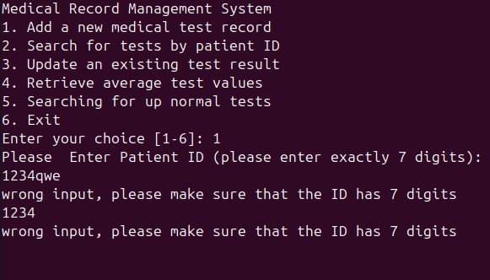

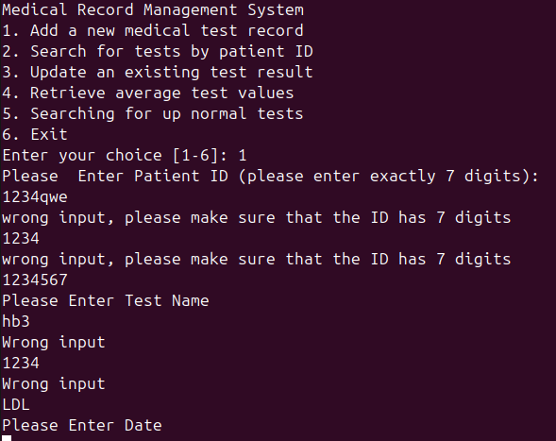

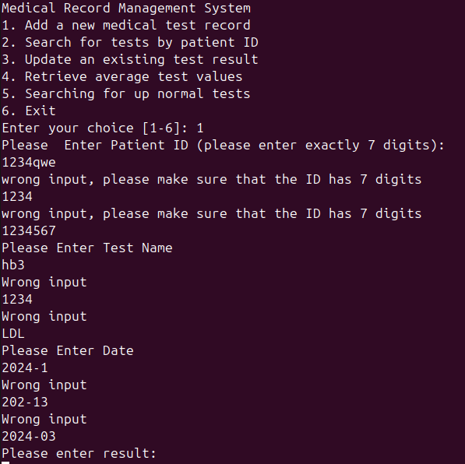

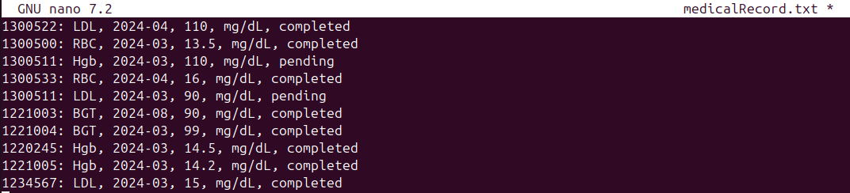

# Function 2:

## Case 1:

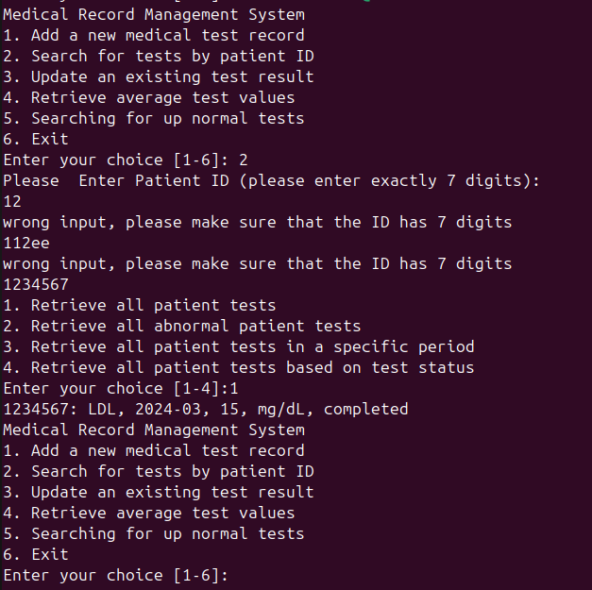

## Case 2:

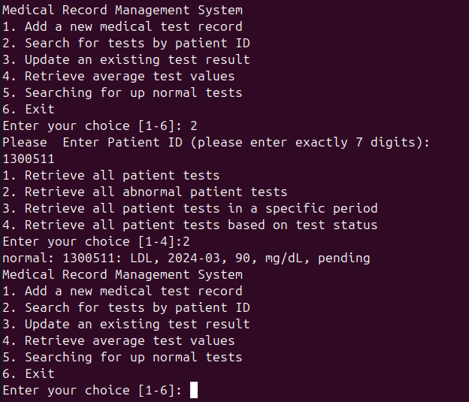

## Case 3:

We changed the date of the id 1300511 to show you that case 3 works

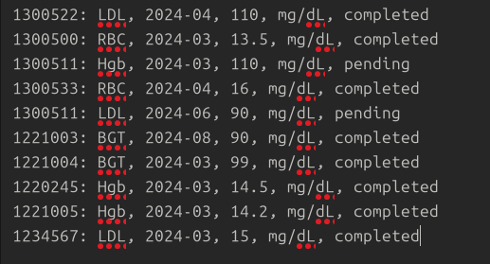

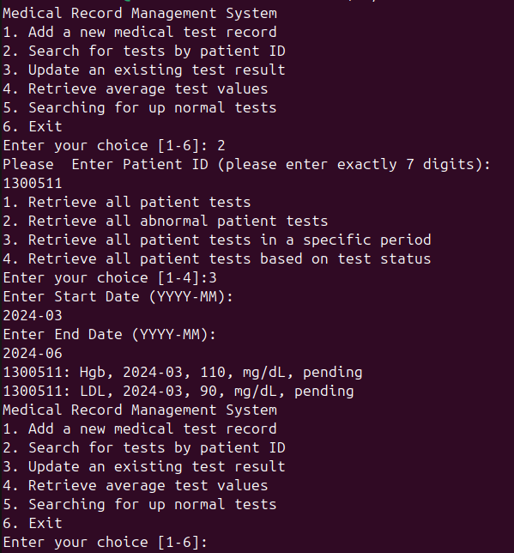

## Case 4:

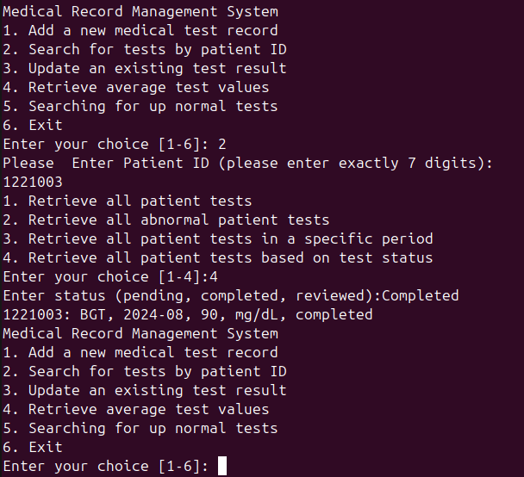

# Function 3:

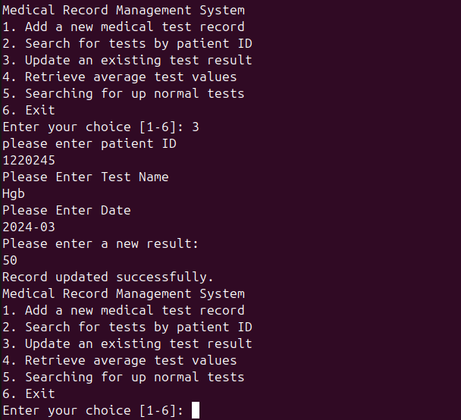

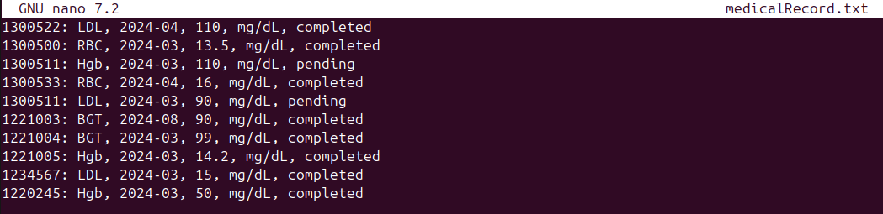

We asked the user to enter the date in case there’s two same tests for the same id

# Function 4:

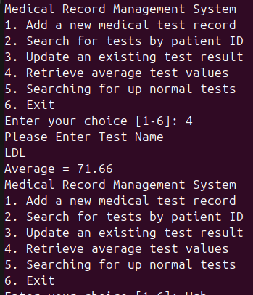

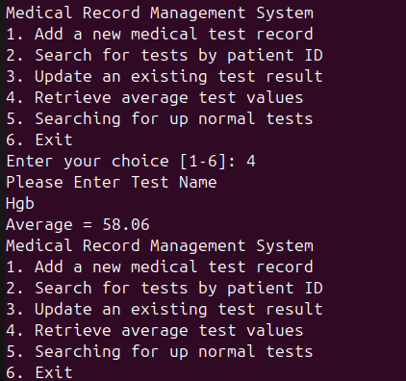

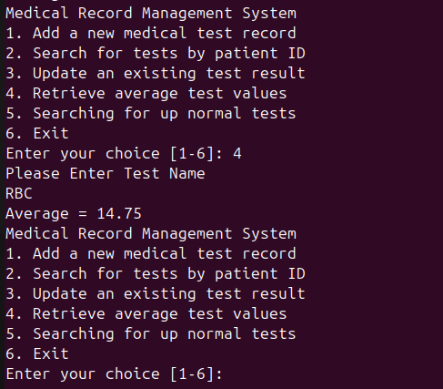

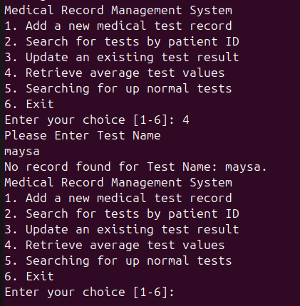

# Function 5:

